Islington College



Programming (CS4001NI)

Coursework 1

**Submitted by:** **Submitted to:**

Prayash Bikram Shah Mr. Sukant Kumar Sahu

16033180 Mr. Weenit Maharjan

Group Computing (C5)

Date: 19th January 2017

Contents

Table of Figures: 2

Class Diagram 3

Car Class: 3

Car to buy Class: 3

Car to rent Class: 4

Pseudocode 5

Car Class: 5

Car to Buy: 5

Car to Rent: 7

Methods Description 10

Testing 11

Test 1: Inspect a car to buy, buy the car, and re-inspect the car to buy 11

Test 2: Display all the details of a car to buy 12

Test 3: Inspect a car to rent, rent the car, and re-inspect the car to rent 12

Test 4: Display the description and total accumulated, before and after renting the car 14

Test 5: Display all the details of a car to rent 15

Test 6: Inspect a car to rent, return the car, and re-inspect the car to rent 16

Error Detection 18

Error 1: Value not displayed 18

Error 2: All details of car to buy not being displayed 20

Error 3: Syntax Errors 22

Conclusion 24

# Table of Figures:

Figure 1 Class Diagram of Car 3

Figure 2 Class Diagram of Car to Buy 3

Figure 3 Class Diagram of Car to Rent 4

Figure 4 Inspection of Car to Buy 11

Figure 5 Buying the car 11

Figure 6 Re-Inspection of Car to Buy 11

Figure 7 Every Details of Car to Buy 12

Figure 8 Inspection of Car to Rent Part 1 12

Figure 9 Inspection of Car to Rent Part 2 13

Figure 10 Renting the Car 13

Figure 11 Re-Inspection of Car to Rent Part 1 13

Figure 12 Re-Inspection of Car to Rent Part 2 14

Figure 13 Description and Total Accumulated before renting car 14

Figure 14 Description and Total Accumulated after renting car 15

Figure 15 All the details of Car to Rent 15

Figure 16 Inspection of Car to Rent Part 1 16

Figure 17 Inspection of Car to Rent Part 2 16

Figure 18 Re-Inspection of Car to Rent after returning car Part 1 16

Figure 19 Re-Inspection of Car to Rent after returning car Part 2 17

Figure 20 Inserting value 18

Figure 21 Inspection of Car to Buy after inserting values 18

Figure 22 Error in Programming 19

Figure 23 Right Codes of Programming 19

Figure 24 Re-Inspection of Car to Buy after solving error 19

Figure 25 Inserting Value Again 20

Figure 26 Inspection of Car to Buy again 20

Figure 27 Selecting Display of Car to Buy 20

Figure 28 Display of Car to Buy before solving error 21

Figure 29 Coding Mistake 21

Figure 30 Coding Solved 21

Figure 31 Proper Display of Car to Buy after solving 22

Figure 32 Syntax error 1 22

Figure 33 Syntax error 2 22

Figure 34 Syntax error 3 23

# Class Diagram

## Car Class:

|  |
| --- |
| Car |
| -CustomerName: String  -Description: String |
| +getCustomerName(): String  +getdescription(): String  +setCustomerName(): void  +display(): void |

Figure 1 Class Diagram of Car

## Car to buy Class:

|  |
| --- |
| CartoBuy |
| -Price: integer  -reg_year: integer  -mlg: integer  -sold: Boolean |
| +getprice(): integer  +getreg_year(): integer  +getmlg(): integer  +getsold(): boolean  +setprice(): void  +CartoBuy(): void  +display(): void |

Figure 2 Class Diagram of Car to Buy

## Car to rent Class:

|  |
| --- |
| CartoRent |
| -rent_date: String  -return_date: String  -admin_fee: Integer  -num_days: Integer  -daily_rate: Integer  -total_acc: Integer  -loan: Boolean |
| +getrent_date(): String  +getreturn_date(): String  +getadmin_fee(): Integer  +getnum_days(): Integer  +getdaily_rate(): Integer  +gettotal_acc(): Integer  +getloan(): boolean  +setdaily_rate(): void  +setadmin_fee(): void  +rentcar(): void  +returnCar(): void  +description(): void  +displayevery(): void |

Figure 3 Class Diagram of Car to Rent

# Pseudocode

## Car Class:

class Car

Customer Name

description

Car (description of car)

Customer Name = "";

description= description;

set Customer Name

Customer Name=new Customer Name;

Get Customer Name

return Customer Name;

get description

return description;

display

print Car Description

if Customer Name = “”

print “ “

else

print Customer Name

## Car to Buy:

class Car to Buy extends Car

price is integer value

registration year is integer value

mileage is integer value

sold is Boolean value

Car to Buy (description, price, registration year, mileage)

description

price=another price

registration year= another registration year

mileage=another mileage

sold=false

get price

return price

get registration year

return registration year

get mileage

return mileage

get sold

return sold

set price (cost)

if (sold is true)

print Car is already sold with price. Car price not negotiable

else

price cost

Car to Buy Customer Name

if sold is true

print The Car is no longer available

else

set Customer Name (Customer Name)

sold as true

display

If sold is false

Print Car Cost with price

Print Registration Year

Print Mileage

## Car to Rent:

class Car to Rent extends Car

rental date is string value

return date is string value

admin fee is integer value

number of days is integer value

daily rate is integer value

total accumulated is integer value

loan is Boolean value

Car to Rent (Description, admin fee, daily rate)

Description

admin fee= another admin fee

daily rate= another daily rate

rental date = ""

return date=""

number of days=0

total accumulated=0

loan is false

get rental date

return rental date

get return date

return return date

get admin fee

return admin fee

get number of days

return number of days

get total accumulated

return total accumulated

get daily rate

return daily rate

get loan

return loan

set daily rate

daily rate= another daily rate

set admin fee

admin fee= another admin fee

rent car (Customer Name, rental date, return date, days)

if loan is true

print This car is not available as it is already rented in rental date for number of days

else

set Customer Name (Customer Name)

rental date=another rental date

return date= another return date

number of days is days

total accumulated is daily rate times number of days and their and admin fee sum

loan is true

return Car

if loan is false

Print The car is available and the rate for renting this car is daily rate per day and Admin fee

else

set Customer Name as " "

rental date is " "

return date is " "

number of days is 0

total accumulated is 0

loan is false

description

s is get description

Print Description of car is s

Print Total Cost

display every

print Daily Rate

print Admin Fee

if loan is true

Print Rental Date

Print Return Date

Print Number of Days

# Methods Description

|  |  |
| --- | --- |
| Methods | Description |
| getCustomerName | This method is for getting the customer name and which returns a string value. |
| getdescription | This method is for getting description and which returns a string value. |
| setCustomerName | This method is for setting the customer name and which returns a string value. |
| display | This method displays all of the print statement with some correct conditions. |
| getprice | This method gets the price of the car and returns an integer value. |
| getreg_year | Getting Registration year of the car and returns an integer value. |
| getmlg | Getting mileage of the car and returns integer value. |
| getsold | Getting true or false which is a Boolean value. |
| setprice | Setting the price of the car and which is an integer so returns a integer value. |
| CartoBuy | This method is for buying the car. |
| getrent_date | Getting the rental date of the car which is in integer so returns a integer value. |
| getreturn_date | Getting the return date of the car which is in integer so returns integer value. |
| getadmin_fee | Getting the admin fee which is in integer so returns integer value. |
| getnum_days | Getting the number of days, a car is being rented which is in integer so returns integer value. |
| getdaily_rate | Getting the daily rate of renting the car which is in integer so returns integer value. |
| gettotal_acc | Getting the total accumulated which is in integer so returns integer value. |
| getloan | Getting true or false whether the car is being rented which is a Boolean value. |
| setdaily_rate | Setting the daily rate of renting the car which is in integer so returns integer value. |
| setadmin_fee | Setting the admin fee which is in integer so returns integer value. |
| Rentcar | This method is for renting the car. |
| Returncar | This method is for returning the rented car. |
| description | This method displays the description. |
| displayevery | This method displays every detail of the car to rent. |

# Testing

## Test 1: Inspect a car to buy, buy the car, and re-inspect the car to buy

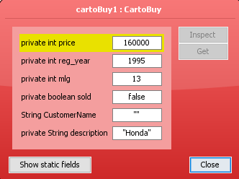

Figure 4 Inspection of Car to Buy

This above figure is the result of inspecting the car to buy before buying the car in which the sold has its default value false and customer name as “”.

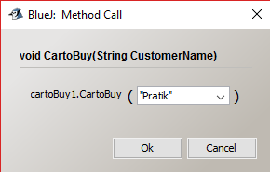

Figure 5 Buying the car

Now when buying the car, we are setting the value of the customer name who is buying the car to Pratik. After this step when we re-inspect the car to buy the value of sold is true and Pratik is shown in customer name as per the figure 6.

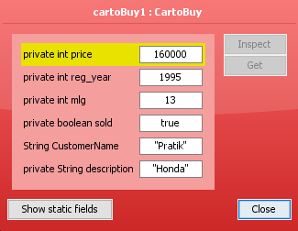

Figure 6 Re-Inspection of Car to Buy

## Test 2: Display all the details of a car to buy

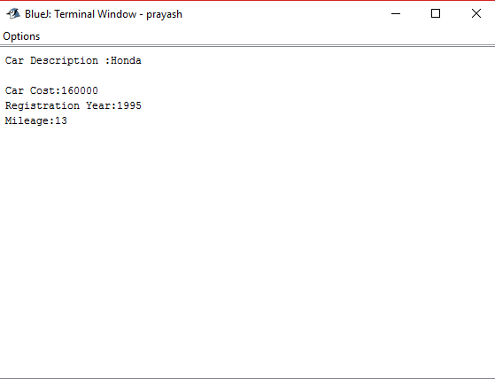

Figure 7 Every Details of Car to Buy

The above figure 7 is the output when we display all the details of car to buy that is Car’s cost, its registration year and mileage.

## Test 3: Inspect a car to rent, rent the car, and re-inspect the car to rent

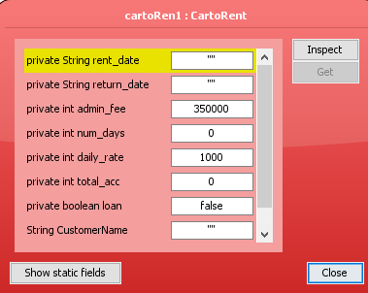

Figure 8 Inspection of Car to Rent Part 1

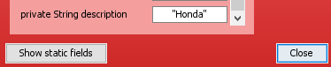

Figure 9 Inspection of Car to Rent Part 2

The above two figures 8 and 9 are the result of inspecting the car to rent in which admin fee, daily rate and description only has values and the loan is set to its default Boolean value false as this car has not been rented.

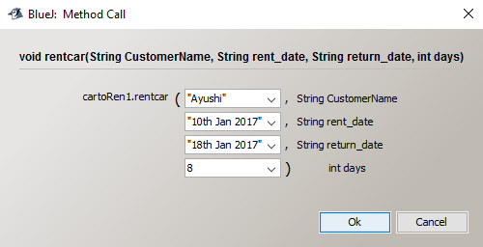

Figure 10 Renting the Car

When we rent the car, we need to input a customer name, rent date, return date and number of days that car is being rented for as per the above figure 10.

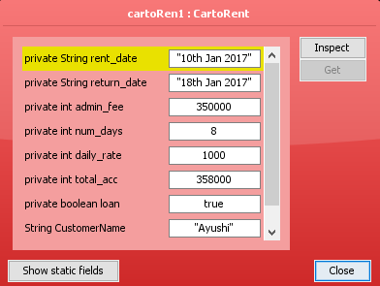

Figure 11 Re-Inspection of Car to Rent Part 1

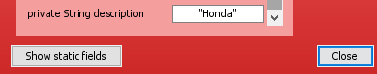

Figure 12 Re-Inspection of Car to Rent Part 2

After renting the car when we re-inspect car to rent the value of loan is set to true which indicates the car has been rented and the rental date, return date, number of days and the customer name is also appeared as seen in above figures 11 and 12.

## Test 4: Display the description and total accumulated, before and after renting the car

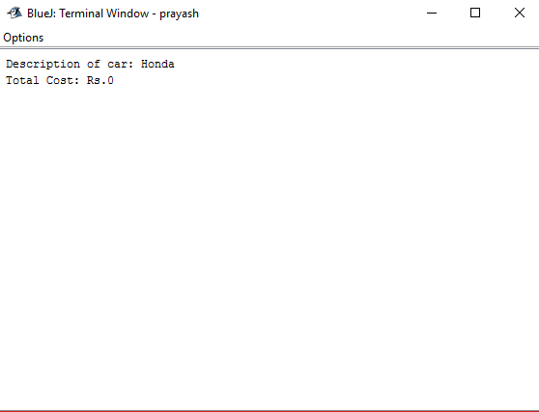

Figure 13 Description and Total Accumulated before renting car

The above figure 13 displays the description of car and total accumulated before renting a car in this case which is Honda and Rs.0 respectively. Now after renting the car and when displayed the description of car and total accumulated the value of total cost changes to 358000 which is the sum of admin fee and the total cost of renting the Honda car for 8 days as shown in the below figure 14.

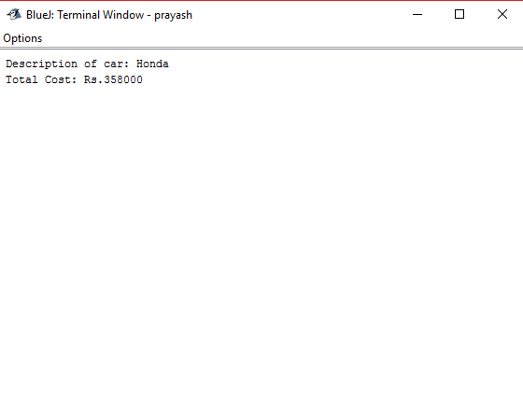

Figure 14 Description and Total Accumulated after renting car

## Test 5: Display all the details of a car to rent

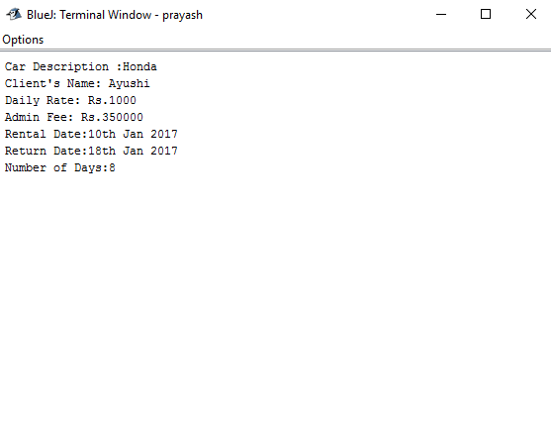

Figure 15 All the details of Car to Rent

The above figure 15 is the output when all the details of car to rent was displayed which shows the car description, Client’s name, daily rate of the car, admin fee, rental date, return date and number of days.

## Test 6: Inspect a car to rent, return the car, and re-inspect the car to rent

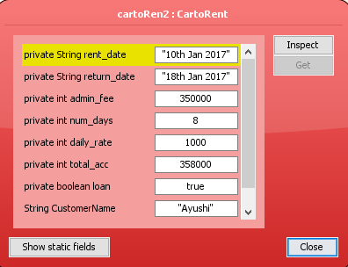

Figure 16 Inspection of Car to Rent Part 1

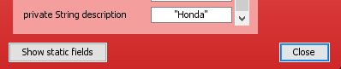

Figure 17 Inspection of Car to Rent Part 2

The above two figures 16 and 17 are the result of inspecting the car to rent after renting the car in which it displays all the values and loan as true.

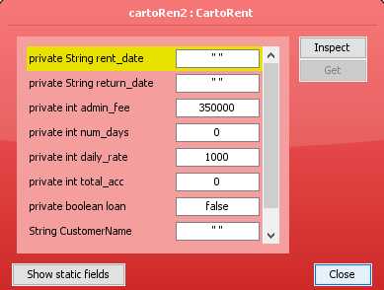

Figure 18 Re-Inspection of Car to Rent after returning car Part 1

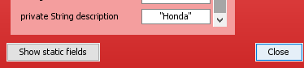

Figure 19 Re-Inspection of Car to Rent after returning car Part 2

Now the above two figures 18 and 19 are the result of inspecting the car to rent after returning the car which displays loan as false and only admin fee, daily rate and description of car has value.

# Error Detection

## Error 1: Value not displayed

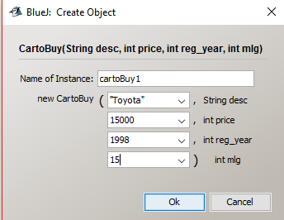

Figure 20 Inserting value

When Inserting values as seen in above figure 20 and after that inspecting the car to buy the price, registration yeah and mileage were showing 0 as their value as shown in the below figure 21.

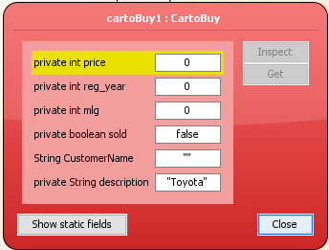

Figure 21 Inspection of Car to Buy after inserting values

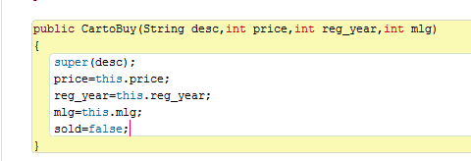

Figure 22 Error in Programming

The above figure 22 is the above location where coding got a bit wrong. I used price=this.price and likewise for registration year and mileage too instead of using this.price=price which was showing the value of price, registration year and mileage 0 while inspecting. After correcting this mistake as shown in figure 23 and again re-inspecting the car to buy the value of price, registration year and mileage were shown as seen in figure 24.

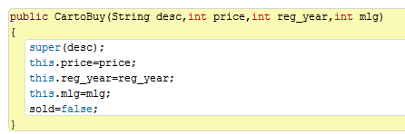

Figure 23 Right Codes of Programming

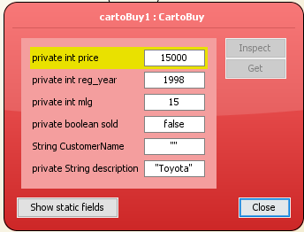

Figure 24 Re-Inspection of Car to Buy after solving error

## Error 2: All details of car to buy not being displayed



Figure 25 Inserting Value Again



Figure 26 Inspection of Car to Buy again

When Inserting values as seen in above figure 25 and after that inspecting the car to buy the price, registration yeah and mileage were showing their value as shown in the below figure 26. But when void display was selected for displaying all the details of car to buy, the output was showing just the car description as seen in figure 28.

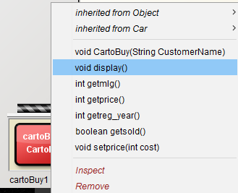

Figure 27 Selecting Display of Car to Buy

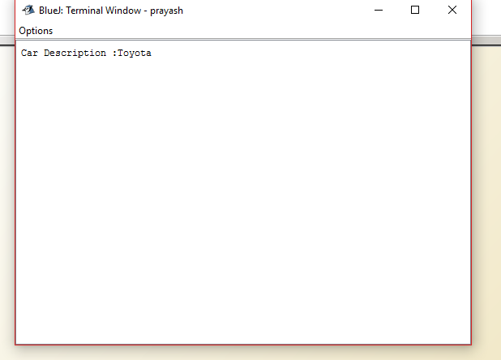

Figure 28 Display of Car to Buy before solving error

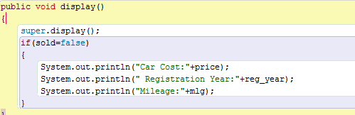

Figure 29 Coding Mistake

The mistake I did was in the is statement where I typed “if (sold=false)” as shown in figure 29 instead of “if(sold==false)” as seen in figure 30. After solving this error and when displaying all the detail of car to buy the output finally gave the car description, registration year and mileage as seen in figure 31.

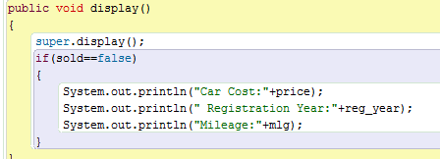

Figure 30 Coding Solved

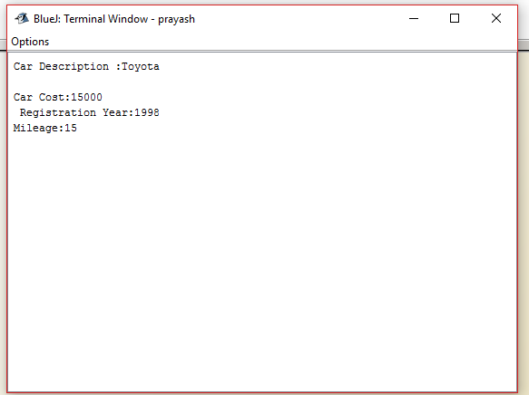

Figure 31 Proper Display of Car to Buy after solving

## Error 3: Syntax Errors

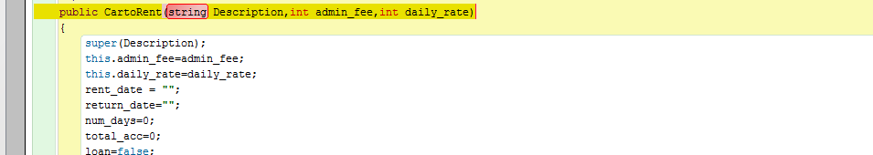

Figure 32 Syntax error 1

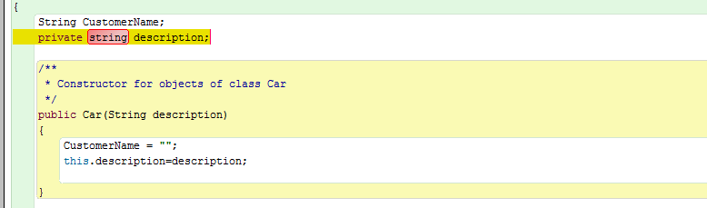

Figure 33 Syntax error 2

The above figure 32 and 33 and even the below figure 34 are the three example of syntax error that I had while compiling my codes.

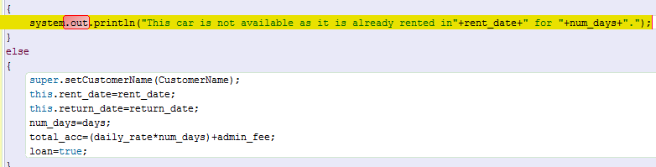

Figure 34 Syntax error 3

# Conclusion

This Coursework was about creating a class to represent a car at a local car dealership with its two option or subclasses which were car to buy and car to rent using Java Programming language. Java programming language was being taught from the beginning of this semester of this module. While doing this project, I went through all the slides tutorial question and every example that I learned or went across while learning java programming language so that it would help me to do this project in a proper manner and easily. Creating this project tested my limits and what I had learned and even helped me learning the things that I had missed out and not understood. This project consists of a car class and two sub classes car to buy and car to rent. Car to buy was for the customer to buy the car from the local dealership while car to rent was for the customers to rent a car for certain period of time and again return back.